Big-O Values for LinkedList and ArrayList
Preparation for CollectionsSpeed

As you have seen with TJArrayList, the java.util.ArrayList<E> maintains a backing "raw" array.
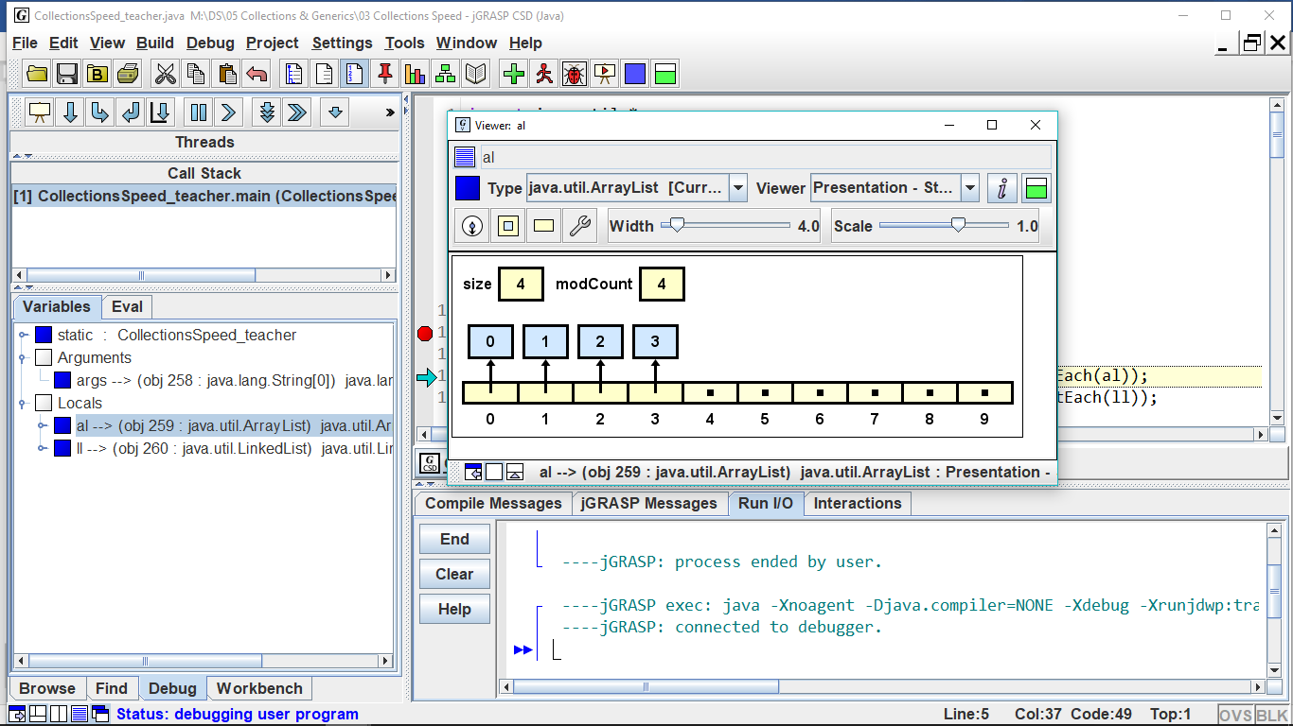

anArrayList

Similar to DLL, java.util.LinkedList<E> maintains a backing doubly linked list of list nodes with a pointer to the last node.

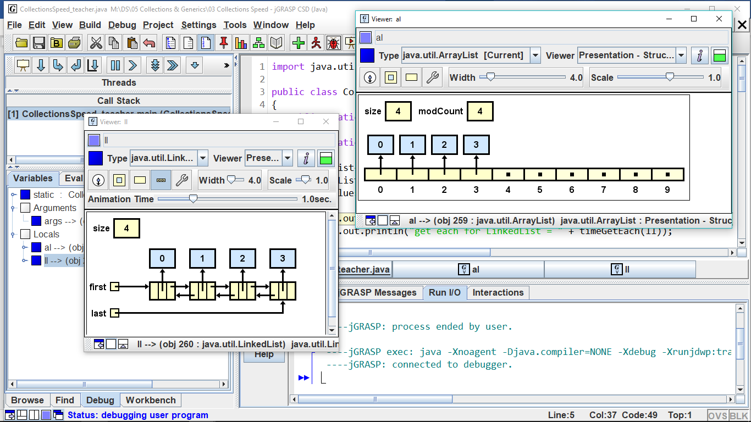

aLinkedList

 | LinkedList | ArrayList
size()
add(o)
add(i, o)
get(i)
set(i, o )
remove(i)
addFirst(o)
addLast(o)
getFirst()
getLast()
removeFirst
removeLast()
Because of their differing structure, the two implementations of List<E> have different Big-O performances. As you fill in the Big-O table, think about when you need to access each element, and when you can jump directly to the element.

Some of these methods are index-based and others are object-based.

Predict the Big-O values and explain why:
 |  | if list is an ArrayList | If list is a LinkedList
1. | for(int i=0; i<list.size(); i++)  total += list.get(i);
2. | while( iter.hasNext() )  if(iter.next().equals("Bob"))  iter.remove();

Let's think about the Big-O for ordered (or sorted) ArrayLists and LinkedLists. "Ordered" means that every time you insert or delete, you must maintain the sorted order of the list.

Predict the Big-O values and explain why:
 |  | if list is an ArrayList | If list is a LinkedList
3. | Searching the list
4. | Inserting an item into the list
5. | Deleting an item
6. | Insert an item that forces a resize
When do you choose to use an ArrayList and when to use a LinkedList? Sometimes Big-O efficiencies make the difference.
- If quick access to the data is important, use a(n) ____________________
- If quick insertion and deletion is important, use a(n) ____________________
- If the amount of data is relatively unchanging, use a(n) _______________________
- If the amount of data changes rapidly and widely, use a(n) ______________________
- If data is to be inserted at the front, use a(n) ___________________because the Big-O is _____
- If data is to be inserted at the mid-point, use ___________________because the Big-O is _____
- If data is to be inserted at the end, use ________________ because the Big-O is ______
- If you are accessing the data by its index, then a(n) ________________ gives you an access time of O(1).

- If you are accessing the data by its index, then a(n) ________________ gives you an access time of O(n).

